BEFORE THE ARIZONA POWER PLANT
AND TRANSMISSION LINE SITING COMMITTEE
IN THE MATTER OF THE APPLICATION OF Eloy valley energy center iii, LLC, IN CONFORMANCE WITH THE REQUIREMENTS OF ARIZONA REVISED STATUTES §§ 40-360, ET SEQ., FOR A CERTIFICATE OF ENVIRONMENTAL COMPATIBILITY AUTHORIZING THE eloy valley energy center iii PROJECT, WHICH CONSISTS OF a 230-KV GEN-TIE LINES THAT WILL CONNECT A UTILITY-SCALE PV SOLAR ARRAY, BESS AND ASSOCIATED PROJECT SUBSTATION LOCATED APPROXI-MATELY EIGHT MILES SOUTH OF eloy, pinal COUNTY, ARIZONA, CONNECTING THE eloy valley energy center iii AND BESS FACILITY TO THE EXISTING western area power admini-stration ed-5 SUBSTATION.

Docket No. L-21375A-25-0252-00256

Case No. 256

NOTICE OF HEARING
A PUBLIC HEARING WILL BE HELD before the Arizona Power Plant and Transmission Line Siting Committee (“Committee”) regarding the Application of Eloy Valley Energy Center III, LLC (“Applicant”) for a Certificate of Environmental Compatibility (“CEC”) to authorize construction of the Eloy Valley Energy Center III Gen-Tie Line Project (“Project”).
The Project will involve the construction of a 230 kilovolt (“kV”) transmission line that will connect a utility-scale photovoltaic solar array (“Solar Facility”) battery energy storage system (“BESS”), and associated Project substation with the existing Western Area Power Administration (“WAPA”) ED-5 Substation. The Project will electrically interconnect the Solar Facility and BESS to the existing WAPA ED-5 Substation, providing solar and storage resources to the Arizona electric grid. The Project will be located near Eloy, in unincorporated Pinal County, Arizona. A map of the Project is attached as Exhibit A.
The hearing on the Application will be held at the Radison Hotel Casa Grande located at 777 N. Pinal Avenue, Casa Grande, Arizona 85122. The hearing will begin on Tuesday, January 20, 2026, at 1:00 p.m. and will continue as necessary through Friday, January 23, 2026, beginning at 9:00 a.m. each day at the same location. If any revisions to the hearing schedule are required, they will be noticed on the Project website at: https://www.nexteraenergyresources.com/eloy-valley-solar.html and on the Arizona Corporation Commission (“ACC”) website at: https://www.azcc.gov/arizona-power-plant/hearings-and-meetings.
PUBLIC COMMENT WILL BE TAKEN IN A SPECIAL EVENING SESSION ON TUESDAY, JANUARY 20, 2026, BEGINNING AT 5:30 P.M., VIA TELEPHONE, ZOOM, OR IN PERSON AT THE RADISON HOTEL CASA GRANDE LOCATED AT 777 N. PINAL AVENUE, CASA GRANDE, ARIZONA 85122. PUBLIC COMMENT MAY BE TAKEN AT THE BEGINNING OF EACH HEARING DAY, OR AT OTHER TIMES DURING THE HEARING, AT THE DISCRETION OF THE COMMITTEE CHAIRMAN.
THE PUBLIC CAN WATCH THE HEARING ONLINE, LISTEN TO THE HEARING VIA TELEPHONE, OR ATTEND IN PERSON. at least 24 hours in advance of the hearing, information regarding online and telephone hearing access, as well as any additional details regarding safety protocols or other revisions to the hearing schedule will be noticed on the Project website at: https://www.nexteraenergyresources.com/eloy-valley-solar.html.
The Chairman may, at his discretion, recess the hearing to a time and place to be announced during the hearing, or to be determined after the recess. The date, time, and place at which the hearing will be resumed will be posted on the above-noted Project and ACC websites. NOTE: NOTICE OF ANY SUCH RESUMED HEARING WILL BE GIVEN; HOWEVER, PUBLISHED NOTICE OF SUCH RESUMED HEARING IS NOT REQUIRED.
If the Committee decides to conduct a tour of the Project, notice that includes a map and itinerary of any such tour will be available at the hearing and posted on the Project and ACC websites. Members of the public may follow the Committee on the tour. During the tour, the Committee may hear testimony at stops concerning elements of the Project. No other discussion or deliberation concerning the Application will occur during the tour. A court reporter or recording device will record any testimony taken on the tour for transcription. Public health and safety protocols specific for the tour will be included on the itinerary. If the Committee decides not to take a tour, the hearing will continue as scheduled.
Maps of the Project site and detailed information about Project facilities are contained in the Application, which is available for inspection at the following locations:
- ACC Docket Control Center, Phoenix Office, 1200 West Washington Street, Suite 108, Phoenix AZ 85007
- Arizona City Community Library, 13254 Sunland Gin Road, Arizona City AZ 85123
- Eloy Santa Cruz Library, 1000 N. Main Street, Eloy AZ 85131
- Project Website: https://www.nexteraenergyresources.com/eloy-valley-solar.html
The Applicant will make available final copies of the pre-filing conference, pre-hearing conference, and hearing transcripts at each of the above locations and website.
Each county, municipal government, and state agency interested in the Project that desires to be a party to the proceedings shall, not less than ten (10) days before the date set for the hearing, file a Notice of Intent to Become a Party with the Director of the Utilities Division, ACC, 1200 West Washington Street, Phoenix, Arizona 85007.
Any domestic non-profit corporation or association formed in whole or in part to promote conservation or natural beauty; to protect the environment, personal health, or other biological values; to preserve historical sites; to promote consumer interests; to represent commercial and industrial groups; or to promote the orderly development of the
area in which the Project is to be located desiring to become a party to the proceedings shall, not less than ten (10) days before the date set for the hearing, file a Notice of Intent to Become a Party with the Director of Utilities Division, ACC, 1200 West Washington Street, Phoenix, AZ 85007.
The Committee may make other persons parties to the proceedings at any time. Any person may make a limited appearance at a hearing by filing a statement in writing with the Director of the Utilities Division, ACC, 1200 West Washington Street, Phoenix, AZ 85007, and the Chairman of the Committee at 2005 North Central Avenue, Phoenix, AZ 85004, not less than five days (5) before the date set for the hearing. A person making a limited appearance will not be a party or have the right to present testimony or cross-examine witnesses.
This proceeding is governed by Arizona Revised Statutes (“A.R.S.”) §§ 40-360 to 40-360.13 and Arizona Administrative Code R14-3-201 to R14-3-220. No substantive communication, not in the public record, may be made to any member of the Committee. The written decision of the Committee will be submitted to the ACC pursuant to A.R.S. § 40-360.07. Any person intending to be a party to the proceedings on the matter before the ACC must be a party to the proceedings before the Committee.
ORDERED this 8th day of December, 2025.
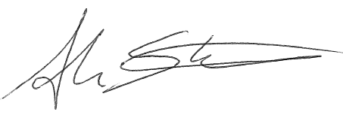

____________________________________
Adam Stafford, Chairman
Arizona Power Plant and Transmission
Line Siting Committee
Assistant Attorney General

Certification of Mailing

ORIGINAL was filed electronically, this ____ day of December, 2025, with:

Utilities Division – Docket Control
ARIZONA CORPORATION COMMISSION
1200 W. Washington Street
Phoenix, Arizona 85007

COPIES of the foregoing e-mailed this ____ day of December, 2025, to:

Tom Van Flein, General Counsel
Arizona Corporation Commission
1200 W. Washington Street
Phoenix, Arizona 85007
legal@azcc.gov
Counsel for Legal Division Staff

Britton Baxter, Do-Director
Ranelle Paladino, Co-Director
Utilities Division
ARIZONA CORPORATION COMMISSION
1200 West Washington Street
Phoenix, Arizona 85007
utildivservicebyemail@azcc.gov

Jeffrey W. Crockett, Esq.
Crockett Law Group PLLC
40 N. Center Street, Suite 106
Mesa, Arizona 85201
jeff@jeffcrockettlaw.com
Attorney for Eloy Valley Energy Center III, LLC

Lisa L. Glennie
Glennie Reporting Services, LLC
1555 East Orangewood
Phoenix, Arizona 85020
admin@glennie-reporting.com
Court Reporter

By: T. Brewer
CEC 256

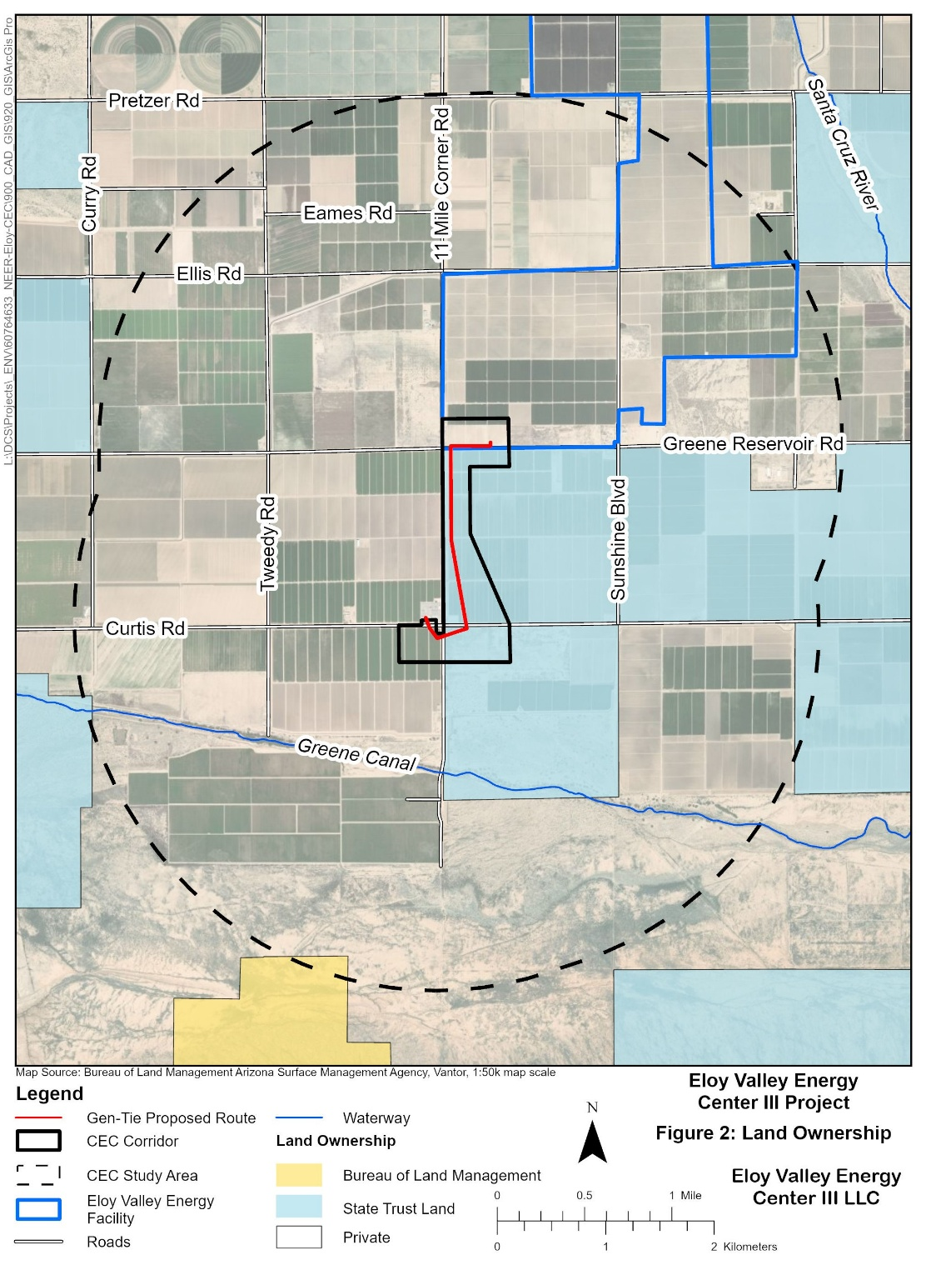
Exhibit A

